Lab 19: EXE With Trojan Code in a New Section
Course Name: Malware Analysis and Reverse Engineering (IAM302)
Student Name: Nguyễn Trần Vinh – SE160258
Instructor Name: Mai Hoàng Đỉnh
Lab Due Date: 18/3/2023

What You Need
A Windows machine, real or virtual. I used a Windows Server 2008 virtual machine.

Purpose
To modify a Windows EXE file and save an altered version containing Trojan code in a new PE section. This gives you practice with very simple features of the Immunity debugger and LordPE

Task 1: Add a Section with LordPE
Copying putty.exe
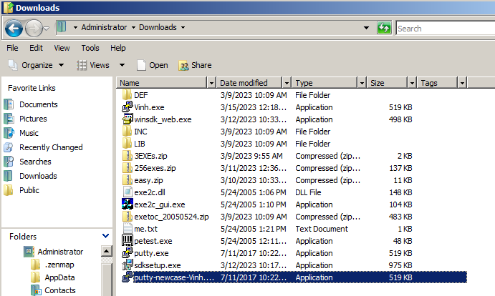

Getting LordPE
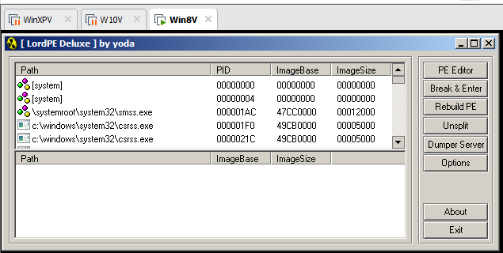

Adding a New Section to the PE Header
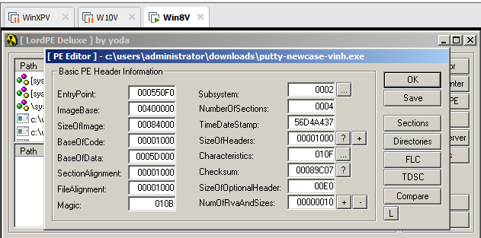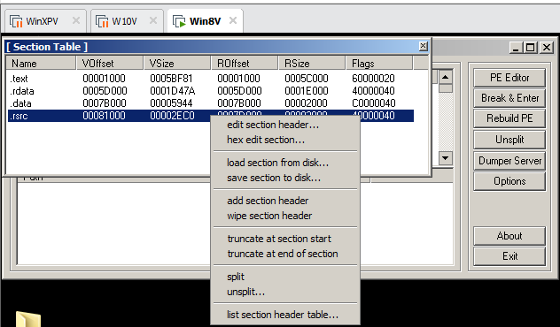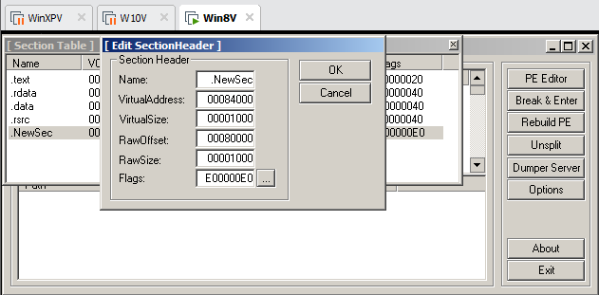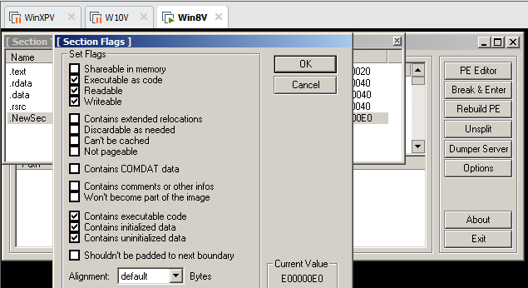

Task 2: Redirecting Code Execution with Immunity
Using Immunity to Examine the NewSec Section
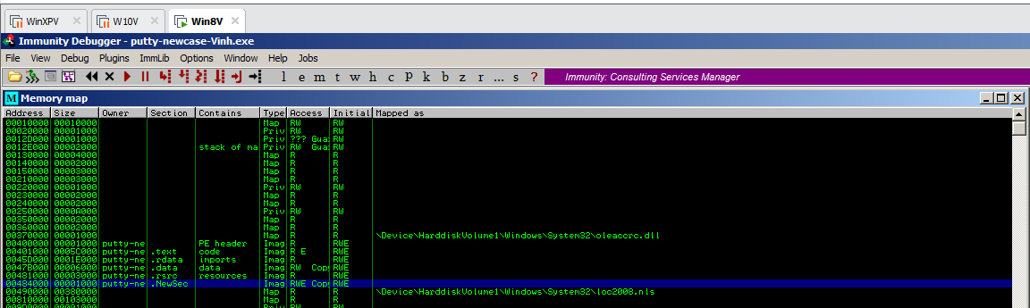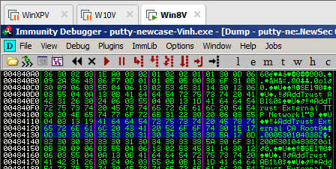

Using Immunity to Redirect Code Execution
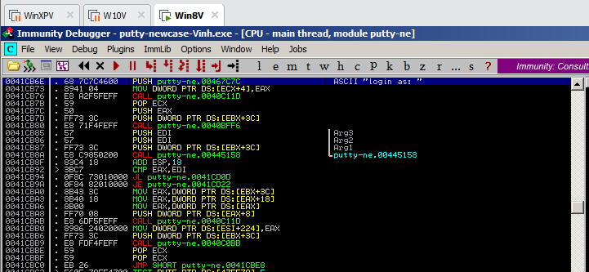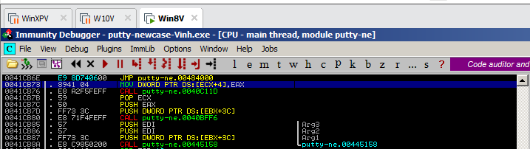

Adding Trojan Code
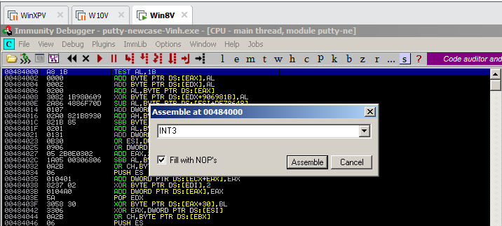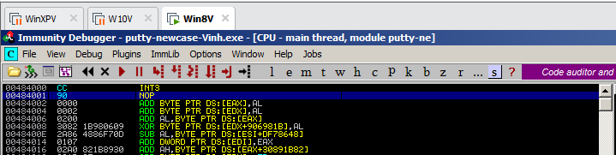

Running the Modified App in Immunity
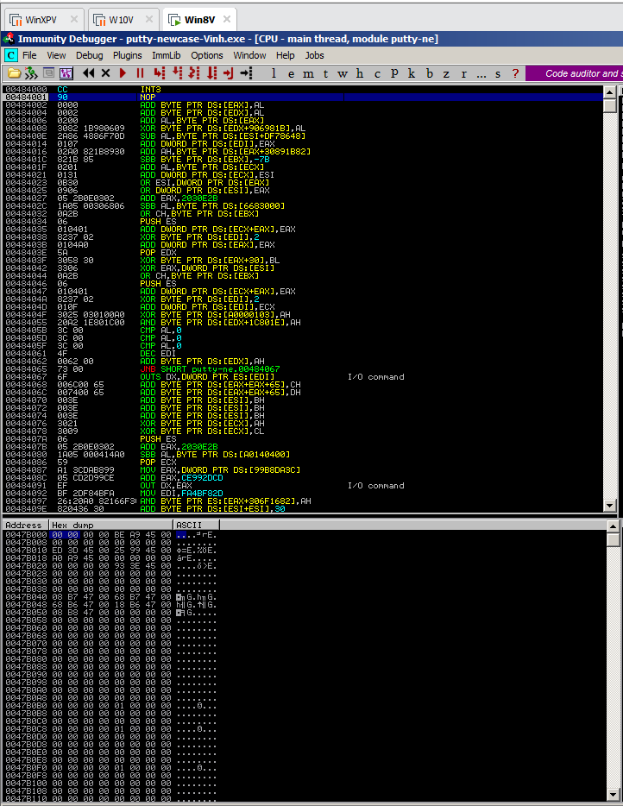

Task 3: Inserting Real Shellcode
Saving the Modified EXE
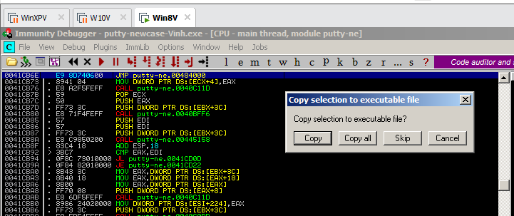

Getting Simple Shellcode
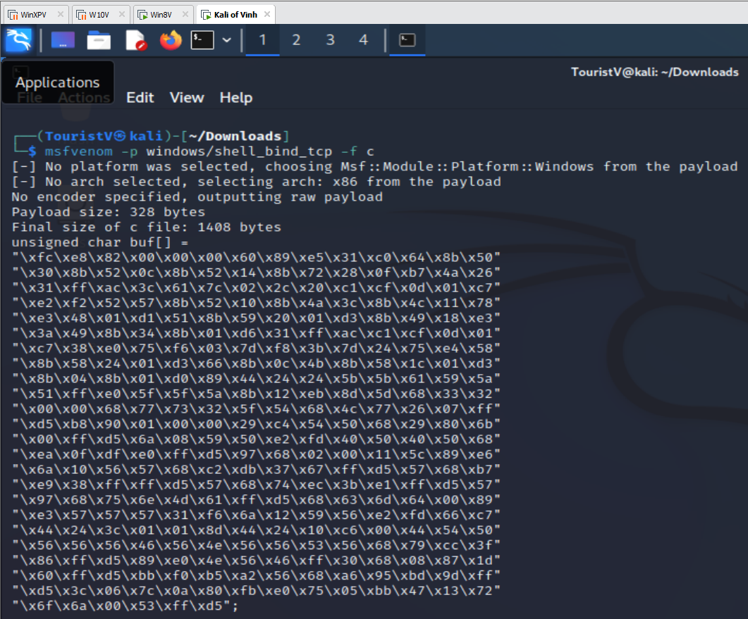
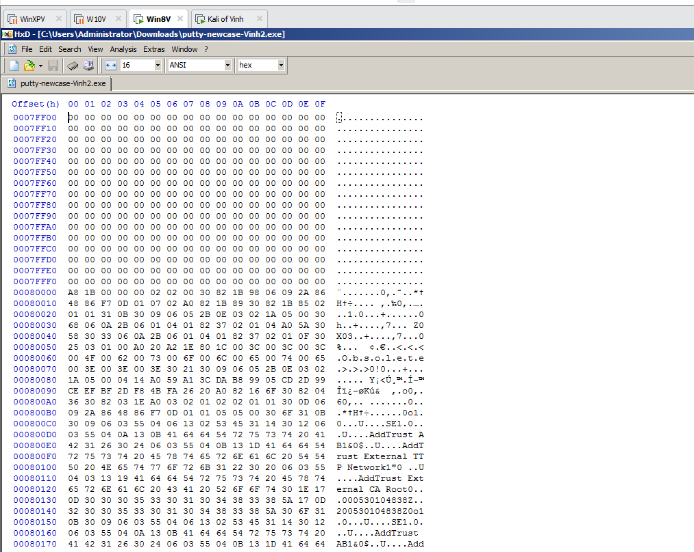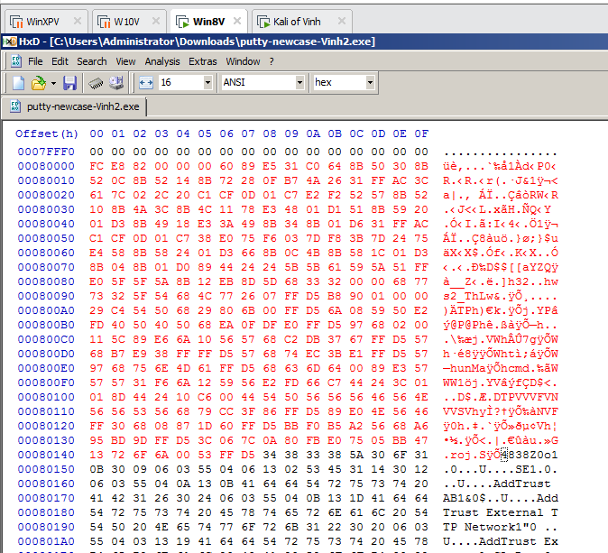

Running the Trojaned Putty
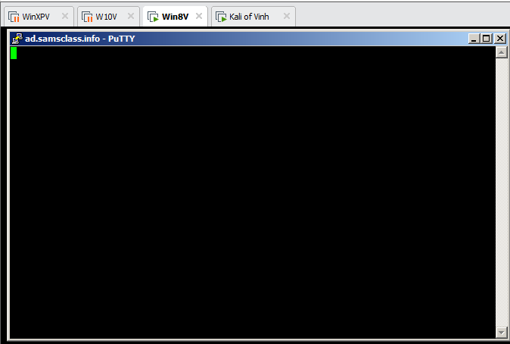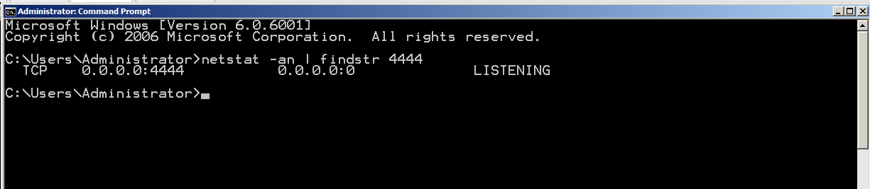

Connecting to the Target
